The Thermistor
Your new component of the day is a thermistor, a resistor whose value changes as a function of temperature in a well-controlled way. This particular device is designed for use in the extruders of 3D printers. It is a Negative Temperature Coefficient (the NTC bit) device meaning that the resistance decreases as the temperature increases. According to Wikipedia NTC devices are well described by the Steinhart-Hart equation that can be written in terms of the temperature T in Kelvin
or
where R0 is the resistance at 25 C (100 kOhm for your thermistor),, and B is 3950. All the numbers being accurate to a few %.
This formula is accurate over a very large range. The device is specified to work from -55 C to +150 C. We are not going to encounter such values in class!
If we can convert the resistance into a voltage that we can measure with an analog-digital converter, then we can build a temperature measuring instrument, a thermometer. Remember that the analog-digital converter on the Feather board has an input range of 0—3.3 V with 12-bit resolution, corresponding to 1 part in 4096 resolution.part in 4096 resolution.

The Thermometer
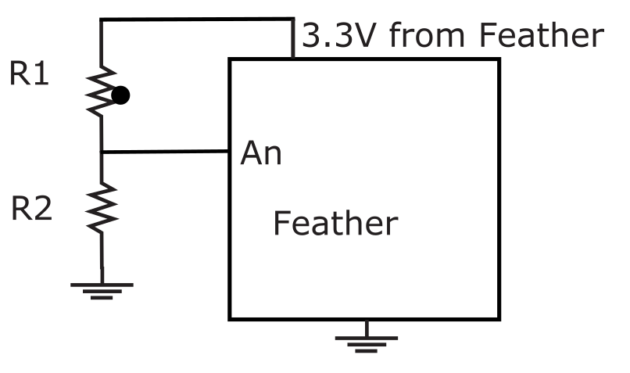
You need to design a circuit to map the resistance of the thermistor onto the 0-3.3V input range of the ADC on your Feather.
I offer you the adjacent sketch as a possible circuit. R1 should be your thermistor and R2 can have the same value as the thermistor at room temperature, 100k. You can use any of the analog input pins A0-A5.

Task 1
a) Use the form of the Steinhart-Hart equation to calculate the resistance of the thermistor at 0C (273K) and at 100C (373K).
At 0C, R = (0.1763)e^{3950/273} = 338844 Ohms.
At 100C, R = (0.1763)e^{3950/373} = 7004 Ohms.

b) Calculate the voltage that you expect at An at the temperatures 0C, 25C, and 50C.
At 0C, An = 3.3 * (100000/ ((0.1763)e^{3950/273} + 100000)) = 0.752 V.
At 25C, An = 3.3 * (100000 / ((0.1763)e^{3950/298}) + 100000) = 1.645 V.
At 50C, An = 3.3 * (100000 / ((0.1763)e^{3950/348}) + 100000) = 2.870 V.

c) Given that the ADC produces an output of 4095 for an input of 3.3V, compute the ADC values that you expect to get at 0C, 25C, and 50C.
At 0C, the ADC value will be floor((0.752 / 3.3) * 4095) * 16 = 14928
At 25C, the ADC value will be floor((1.645 / 3.3) * 4095) * 16 = 32565
At 50C, the ADC value will be floor((2.870/ 3.3) * 4095) * 16 = 56976

d) Write a program that uses an AnalogIn to read the voltage on your analog input and print the value about once a second. Verify that you get a sensible reading at room temperature and paste the properly commented program below.
# Ben Kallus
# Reads the voltage on A0 and prints it once per second.
# At room temperature, I have verified that the reading is reasonable.

from board import *
from analogio import AnalogIn
from time import sleep

PIN = A0

def main():
pin = AnalogIn(A0)
while True:
print(f"Voltage: {pin.value / 65535 * 3.3}")
sleep(1)

main()

e) Add code to convert your ADC value into a resistance value and thence to a temperature, which the program should print. Paste your re-commented program below.
# Ben Kallus
# Prints the temperature once per second

from board import *
from analogio import AnalogIn
from time import sleep
from math import log

PIN = A0
R2 = 100000
R_INF = 0.1763

def main():
pin = AnalogIn(A0)
while True:
V = pin.value / 65535 * 3.3
R1 = -(V-3.3)*R2 / V
print(f"Voltage:\t{V}")
print(f"Resistance:\t{R1}")
print(f"Temperature:\t{3950 / log(R1 / R_INF)}")
print()
sleep(1)

main()

f) Test with the temperature references in the lab and record your results below.
The ice was 277.52 K, and the hot water was 353.435 K.

g) Discuss the accuracy of your thermometer.
The thermometer was very accurate. It was within a degree of your thermometer on both measurements.

